ASSIGNMENT 2
FINAL LAB TASKS BY OM 2280156
COURSE CC

LAB 9b

Resource Group Created
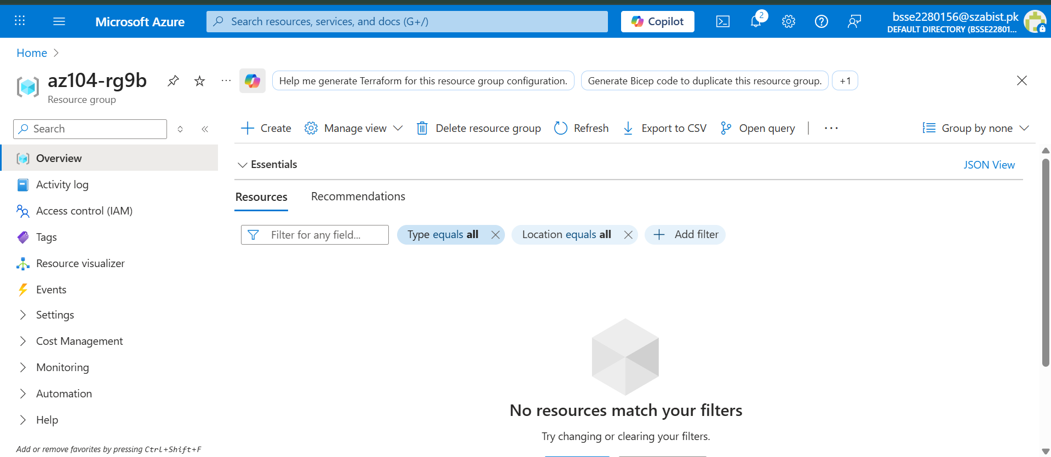

Azure Container Instance Basic Configuration
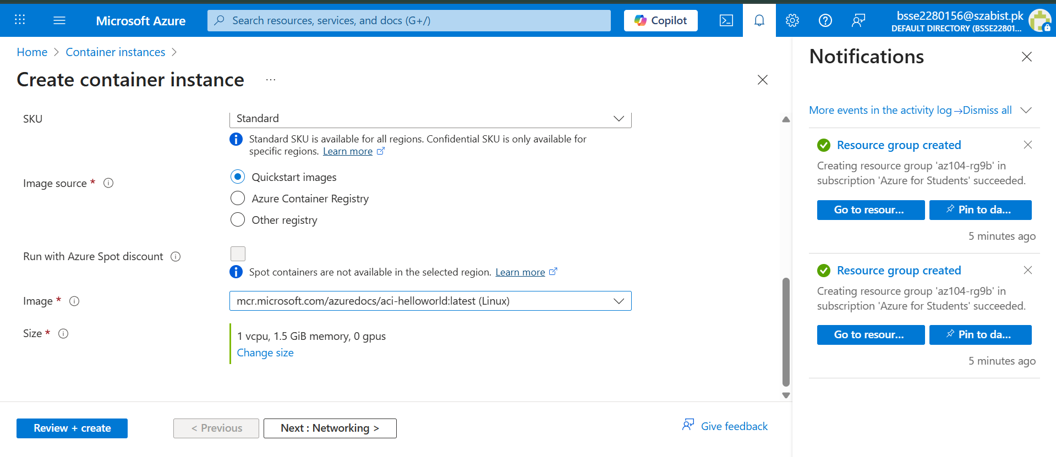

Networking tab showing Public IP + Port 80

Container Networking Configuration
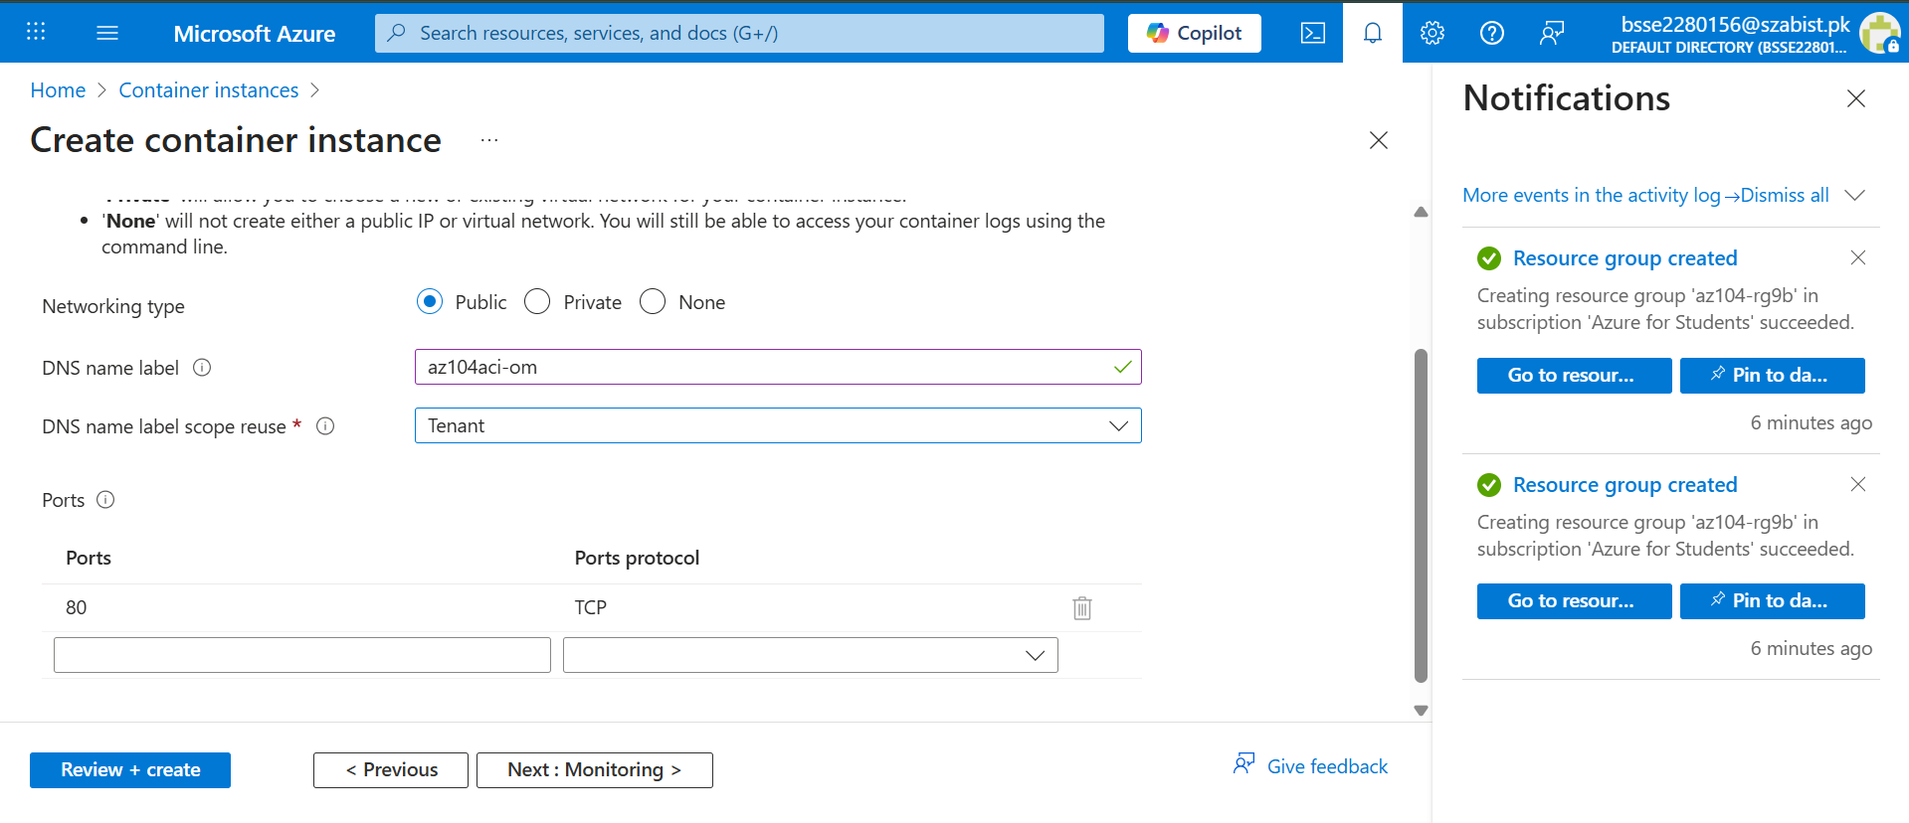

Azure Container Instance Validation Successful
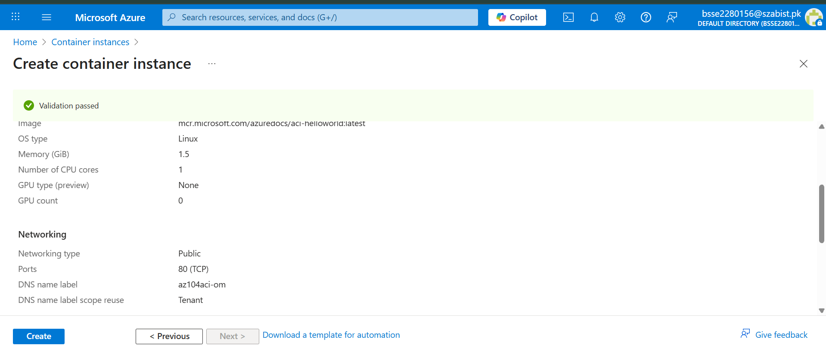

Azure Container Instance Deployment Successful
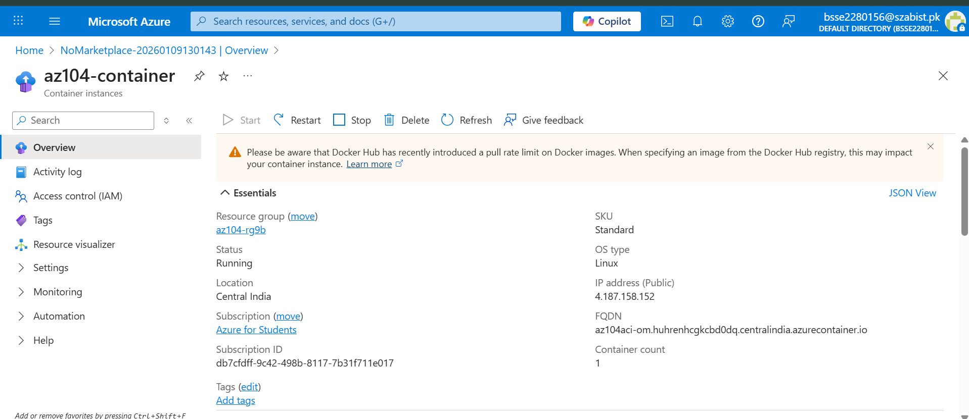

Azure Container Instance Overview

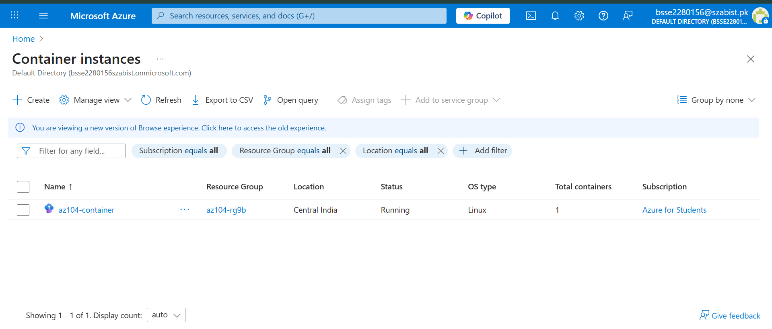

Azure Container Instance Running Successfully
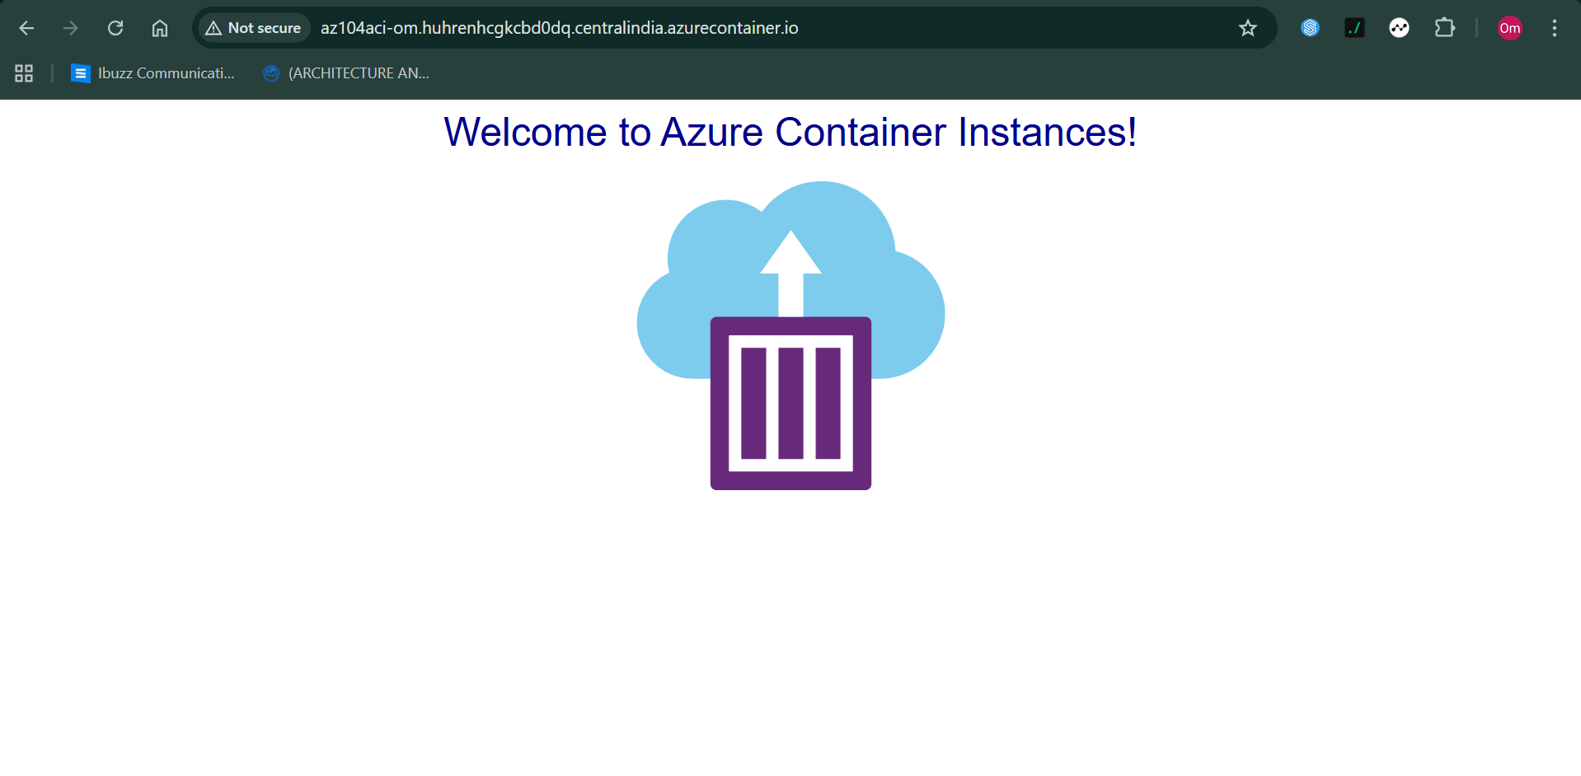

In this lab, an Azure Container Instance was successfully deployed using a public
container image. The container was configured with a public IP address and accessed
through its DNS name. This demonstrates how Azure Container Instances can be used
to run containerized applications without managing virtual machines.

